Time Complexity Part 2

Contents

I. Introduction 3

1. Why do we study time and space complexity? 3

2. Time Complexity 5

3. Asymptotic Analysis 5

4. Examples and Comparisons 6

Compare $100 * log(n)$ vs. $n2$ 6

5. Big O Notation 6

6. Examples 7

Find the time complexity of $fn=10n2+50n+6$ 7

Find the time complexity of $fn=600n3+5n2+40nn+46 logn$ 7

Find the time complexity of $fn=60n3logn+40n3$ 8

Find the time complexity of $fn=500$ 8

Find the time complexity of $f(n,m)=40n3+20n2+59mm​+10m+6$ 9

Some examples: 9

7. Why Do We Neglect Lower-Order Terms in Big O? 10

II. Issues with Big O Notation 11

1. Big O Hides Constant Factors 11

2. Big O Doesn’t Help with Small Inputs 11

3. Big O Doesn't Show Actual Behaviour 11

4. Big O Assumes Large Inputs 12

5. When Should You Trust Big O? 12

III. Space Complexity 13

1. Analysing Space Step-by-Step 13

Example 1: Basic Variables 13

Example 2: Array of Size n 13

Example 3: 2D Array of Size n×n 14

2. Space Can Change Over Time 14

IV. Time Limit Exceeded (TLE) 15

What is it? 15

How to Avoid? 15

Example: 15

Big O is deceiving 16

When Do You Get TLE? 16

What Happens Under the Hood 16

# Introduction

## Why do we study time and space complexity?

* Imagine **Uday** and **Darshan each have written an algorithm to sort ${10}^{6}$ number.**

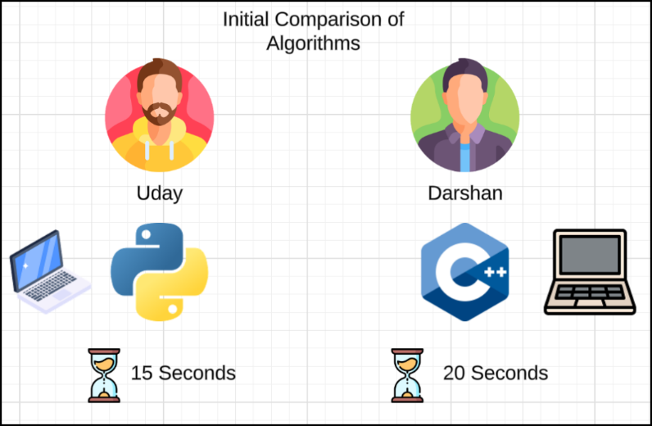

|  |  |  |
| --- | --- | --- |
| Initial Comparison of Algorithms | | |
| Person | **Uday** | **Darshan** |
| Language | Python | C++ |
| Time Taken | 15 Seconds | 20 Seconds |

Looks like **Uday** is better, but **their systems differ**...

* After Giving **Darshan** a Better System (Mac)

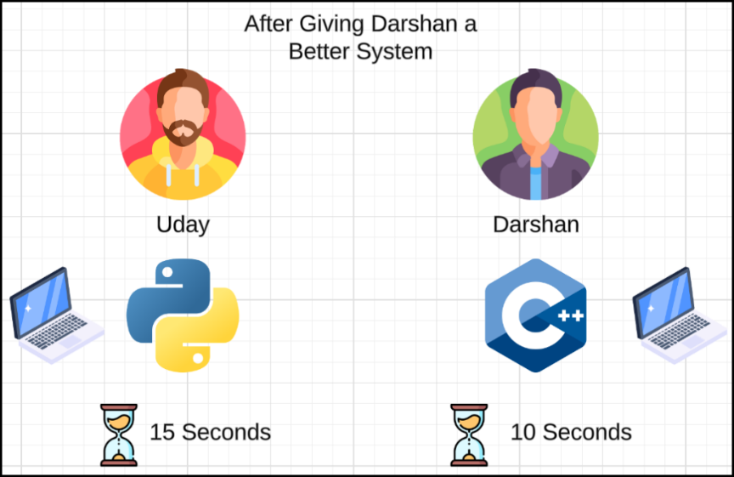

|  |  |  |
| --- | --- | --- |
| After Giving Darshan a MAC | | |
| Person | **Uday** | **Darshan** |
| Language | Python | C++ |
| Time Taken | 15 Seconds | 10 Seconds |

Now Darshan looks better. But **Python vs C++ is unfair**...

* 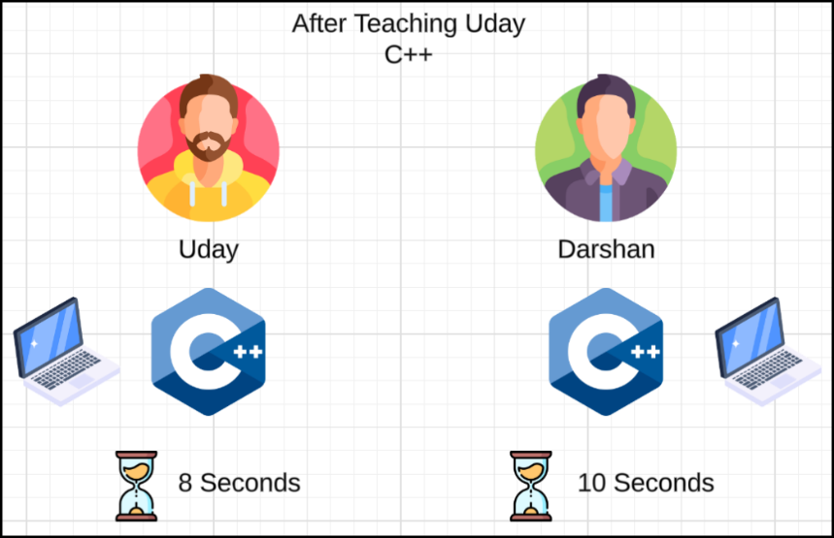After Teaching Uday C++ (Equal Language)

|  |  |  |
| --- | --- | --- |
| After Teaching Uday C++ | | |
| Person | **Uday** | **Darshan** |
| Language | C++ | C++ |
| Time Taken | 8 Seconds | 10 Seconds |

Uday wins... but what about **environment differences**?

* Factoring in Environment (Antarctica vs Volcano)
  + Uday is sitting in Antarctica.
  + 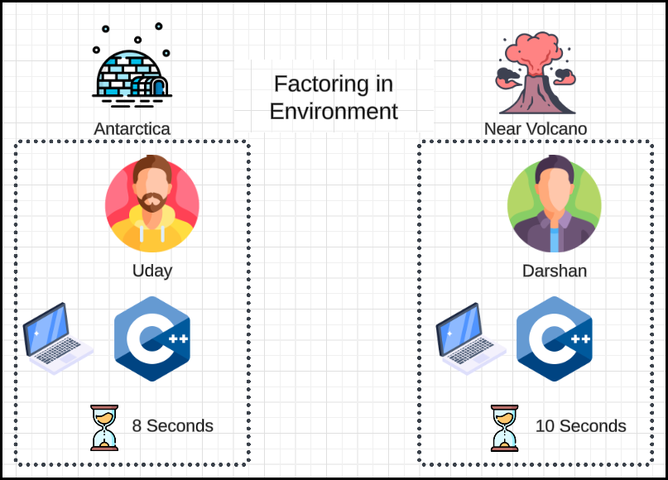Darshan is sitting near a Volcano.

|  |  |  |
| --- | --- | --- |
| Factoring in Environment | | |
| Person | **Uday** | **Darshan** |
| Environment | Antarctica | Volcano |
| Language | C++ | C++ |
| Time Taken | 8 Seconds | 10 Seconds |

Still not fair. **Volcano overheats system**.

* Final: Same Language, Same Machine, Same Env

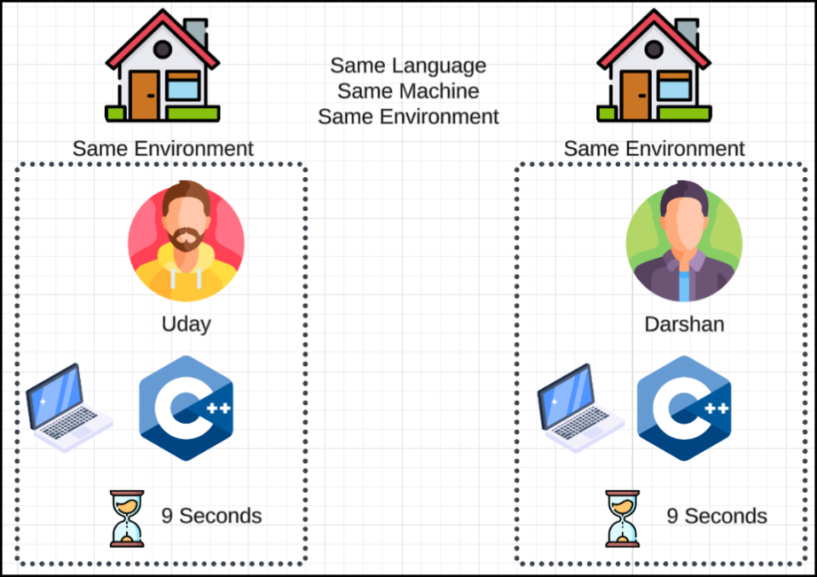

|  |  |  |
| --- | --- | --- |
| Same Language, Same Machine, Same Environment | | |
| Person | **Uday** | **Darshan** |
| Environment | Home | Home |
| Language | C++ | C++ |
| Time Taken | 9 Seconds | 9 Seconds |

* To understand how efficiently our code runs irrespective of hardware, programming language, or environmental conditions.
* Execution time is not reliable because:
  + Different machines (slow vs. fast CPU).
  + Different languages (e.g., Python is slower than C++).
  + External conditions (e.g., temperature, memory availability).

## Time Complexity

* To compare algorithms fairly:
  + Count number of **operations** or **iterations**.
  + This gives a machine-independent measure of performance.

## Asymptotic Analysis

* It is the study of algorithm performance for large input sizes.
* Helps us ignore unimportant details and focus on growth rate.
* This includes notations like **Big O**, **Theta**, and **Omega** (though focus is mostly on Big O for now).

## Examples and Comparisons

### Compare $100 * log(n)$ vs. $\frac{n}{2}$

* For small n,
  + $\frac{n}{2}$ is faster.
* For large n,
  + $100 * log{(n)}$ becomes faster.
* A graph would show the point where the better algorithm switches.

## Big O Notation

* Definition
  + Describes the upper bound on time (i.e., worst-case performance).
  + Used to classify algorithms by how their run time grows with input size $n$.
* How to Calculate
  1. Count the operations based on input size.
  2. Ignore lower-order terms (e.g., $n^{2} + n + 1$ → focus on $n^{2}$).
  3. Ignore constant coefficients (e.g., $5n$ → just $n$).
* Example:

for (int i = 0; i < n; i++) {

// do constant work

}

* + - Number of iterations: $n$
    - Work per iteration: constant
    - Time Complexity: $O(n)$

## Examples

### Find the time complexity of $\boxed{f\left(n\right)=10n^{2}+50n+6}$

* Step 1: Count the operations based on input size
  + This is already provided:
 $f(n) = 10n² + 50n + 6$

   - Each term corresponds to work done as input size $n$ increases.
* Step 2: Ignore lower-order terms
  + We identify the order of each term:
    - $10n²$ → order = 2
    - $50n$ → order = 1
    - 6 → order = 0
  + Keep the highest-order term and discard the rest:
$$f(n)≈10n^{2}$$

* Step 3: Ignore constant coefficients
  + We remove the coefficient 10 (constants do not affect growth rate):

$$\boxed{TC=O\left(n^{2}\right)}$$

### Find the time complexity of $\boxed{f\left(n\right)=600n^{3}+5n^{2}+40n\sqrt{n}+46 \log{n}}$

* Step 1: Count the operations based on input size
  + The number of operations is already represented as:
$$\boxed{f\left(n\right)=600n^{3}+5n^{2}+40n\sqrt{n}+46 \log{n}}$$

* Step 2: Ignore lower-order terms
  + We identify the order (growth rate) of each term:
    - $600n^{3}$ → order = 3
    - $5n^{2}$ → order = 2
    - $40n\sqrt{n}$ → ${40n}^{1.5}$ → order = 1.5
    - $46 \log{n}$ → order < 1
  + The highest order term is: $n^{3}$. So, we discard the rest and keep only:
$$f(n) ≈600n^{3}$$

* Step 3: Ignore constant coefficients
  + Remove the constant 600 as it does not affect asymptotic growth:

$$\boxed{TC=O\left(n^{3}\right)}$$

### Find the time complexity of $\boxed{f\left(n\right)=60n^{3}\log{n}+40n^{3} }$

* Step 1: Count the operations based on input size
  + The number of operations depends on two terms:
$60n^{3}\log{n}$

$40n^{3}$

* Step 2: Ignore lower-order terms
  + Compare the order of growth:
    - $60n^{3}\log{n}$ grows faster than $40n^{3}$ for large n, because the logarithmic factor increases.
    - Therefore, $40n^{3}$ is a lower-order term and can be ignored.
$$f(n) ≈60n^{3}\log{n}$$

* Step 3: Ignore constant coefficients
* Remove the constant 60 to simplify the expression:

$$\boxed{TC=O\left(n^{3}\log{n}\right)}$$

### Find the time complexity of $\boxed{f\left(n\right)=500 }$

* This can be written as $f\left(n\right)=500n^{0}$
* Higher order term is $n^{0}$.
* Ignore the constant coefficient 500.
$$f(n) ≈ n^{0}$$

* Time Complexity is:

$$\boxed{TC=O\left(n^{0}\right)=O\left(1\right)}$$

### Find the time complexity of $f(n,m)=40n^{3}+20n^{2}+59m\sqrt{m}​+10m+6$

* Step 1: Count the operations based on input size
  + We are given a function with two variables,
  + $n$ and $m$, and the number of operations is:
$$\boxed{f(n,m)=40n^{3}+20n^{2}+59m\sqrt{m}​+10m+6}$$

* Step 2: Ignore lower-order terms
  + Group by variable:
    - Terms with n: $40n^{3}, 20n^{2}$
    - Terms with m: $59m\sqrt{m}​, 10m$
    - Constant term: 6
  + Keep the highest-order term for each variable group:
    - From n: Keep $40n^{3}$, drop $20n^{2}$
    - From m: Keep $59m\sqrt{m}$, drop $10m$
    - Drop constant term 6
$$f(n,m)≈40n^{3}+59m\sqrt{m}$$

* Step 3: Ignore constant coefficients
  + Drop constants 40 and 59:

$$TC = O(n^{3}+m\sqrt{m})$$

### Some examples:

$$\boxed{f\left(n,m\right)=4nm+5n^{2}m}$$

$$f(n,m)≈4nm+5n^{2}m$$

$$f(n,m)≈5n^{2}m$$

$$\boxed{TC=O\left(n^{2}m\right)}$$

$$\boxed{f\left(n,m\right)=nm^{2}+n^{2}m}$$

* Step 1: Count the operations based on input size
  + The function consists of two terms:
$nm^{2}$

$n^{2}m$

* Step 2: Ignore lower-order terms
  + In this case, you cannot ignore either term, because:
    - If $n≫m$ then $n^{2}m$ dominates.
    - If $m≫n$ then $nm^{2}$ dominates.
  + Without knowing the relationship between n and m, both are significant.
  + So, we keep both terms.
* Step 3: Ignore constant coefficients
  + There are no constants here to remove, so we retain both terms as-is.

$$\boxed{TC=O\left(nm^{2}+n^{2}m\right)}$$

## Why Do We Neglect Lower-Order Terms in Big O?

* When analysing an algorithm's **time complexity**, we often **remove lower-order terms**. But **why is this justified**?
* Let’s consider:
 $$f(n)=n^{2}+n$$

 + Case 1: Small Input, $n=100$
 $$f(100)={100}^{2}+100=10,000+100=10,100$$

   - Now, compute the **contribution of the lower-order term** n:
 $$\frac{n}{n^{2}+n} 100 = \frac{100}{10100} 100≈0.99\%$$

 + Case 2: Realistic Input Size, $n = {10}^{5}$
 $$f(n)={({10}^{5})}^{2}+{10}^{5}={10}^{10}+{10}^{5}$$

 ${10}^{10} = 10,00,00,00,000$  - , ${10}^{5} = 1,00,000$
 ${10}^{10}+{10}^{5} ≈ {10}^{10}$

 + Now compute the contribution:
$$\frac{{10}^{5}}{{10}^{10}} 100 = {10}^{-5} X 100 = 0.001\%$$

* Lower-order terms are negligible when the input size is large.
* Big O focuses on large inputs—where scalability matters most.
* Dropping smaller terms helps simplify and focus on what really dominates performance.

# Issues with Big O Notation

* Big O notation gives a high-level idea of how the number of operations (or time/space required) grows as input size $n$ increases.
* It focuses on the order of growth and **ignores constants** and **less significant terms**.

## Big O Hides Constant Factors

* Suppose you have two algorithms:
  + Algorithm A → takes $100n²$ operations
  + Algorithm B → takes $4n²$ operations
* Big O for both is $O(n²)$, but clearly, B is better than A.
* Big O **hides** these constant factors (like 100 vs 4), even though they significantly affect performance in practice.

## Big O Doesn’t Help with Small Inputs

* Consider:
  + Algorithm C → **10⁴ × n** operations → O(n)
  + Algorithm D → **5n²** operations → O(n²)
* Example:
  + If n = 10
    - C → $10⁴ * 10$ = 100,000 operations
    - D → $5 * 100$ = 500 operations
* Despite being **O(n²)**, **D is far better** for small n.

## Big O Doesn't Show Actual Behaviour

* Big O gives a qualitative understanding (growth rate) but not the quantitative cost (actual number of steps).
* So, two **O(n²)** algorithms may perform very differently due to hidden constants or lower-level optimizations.

## Big O Assumes Large Inputs

* It’s designed for scalability analysis.
* But real-world systems often work with small or mid-sized data, making raw operation count more relevant than asymptotic behaviour.

## When Should You Trust Big O?

* **When input $n$ is very large** → Big O is useful for comparing algorithms.
* When input n is known and small → **count actual operations** instead of relying on Big O.

# Space Complexity

* Space Complexity refers to the total amount of memory used by an algorithm as a function of input size, including:
  + Input variables
  + Temporary variables
  + Data structures (arrays, lists, etc.)
  + Function call stack

## Analysing Space Step-by-Step

### Example 1: Basic Variables

|  |
| --- |
| int x = n;  int y = 10;  double d = 10.0;  long l = 123456789; |

* Memory usage:
  + int → 4 bytes each → 2 integers = 8 bytes
  + double → 8 bytes
  + long → 8 bytes
  + Total space used = 4 + 4 + 8 + 8 = 24 bytes
* This is independent of input size 𝑛

$$\boxed{Space Complexity=O\left(1\right)}$$

### Example 2: Array of Size n

|  |
| --- |
| int x = 4;  int y = 10;  double d = 10.0;  int arr[n]; |

* Each integer takes 4 bytes. So, for 𝑛 integers:
  + $Space used = 4n$ bytes
* Other variables (e.g., int x = 10) might take a few more bytes, say 16 total, so:
$Total space=4n+16$

* Now apply Big O rules:
  + Remove lower-order terms: keep $4n$
  + Remove constant coefficient: $4$

$$\boxed{Space Complexity=O\left(n\right)}$$

### Example 3: 2D Array of Size n×n

int matrix[n][n];

* Each integer takes 4 bytes:
$$n×n=n^{2} ⇒ Space used = 4n^{2} bytes$$

* Apply Big O simplification:

$$\boxed{SC=O\left(n^{2}\right)}$$

## Space Can Change Over Time

* Realistically, space usage **can increase and decrease** as your program runs:

|  |  |
| --- | --- |
| Time | Memory Used |
| t = 0 | 0 MB |
| t = 1s | 1 GB |
| t = 2s | 2 GB |
| t = 3s | 3 GB |
| t = 4s | 1.5 GB |

* Although the memory usage fluctuates, **space complexity is defined as the peak usage**, i.e.:

$$\boxed{SC=Maximum memory used at any point in time}$$

# Time Limit Exceeded (TLE)

### What is it?

* When your code takes longer than allowed (e.g., >1 second on ${10}^{8}$ operations).

### How to Avoid?

* Estimate time:
* Assume 1 second ≈ ${10}^{8}$ operations.
* If your algorithm does more than that for the given input constraints, you'll get TLE.

### Example:

Given Problem:

$$1 <= n <= {10}^{6} \\ 0 <= A[i] <= {10}^{9}$$

Where n in the number of elements and A[i] is array element.

* If you have written an algorithm for the above given problem and the algorithm executes $5n^{2}$ operations.
* The problem has an input where $n = {10}^{6}$
  + Then the number of operations =
 $$5n^{2} = 5 * {{10}^{6}}^{2}=5 * {10}^{12}$$

 + Too much! Likely TLE.
* Reduce the operation to $n log n$ or better.
* If wrote another algorithm and we reduced the number of operations to
$$2*n*\log{n}$$

* Now calculate **number of operations** for the input size $n = {10}^{6}$

$$= 2 * {10}^{6} * \log_{2}{{10}^{6}}$$

$$= 2 * {10}^{6} * \log_{2}{2^{20}}$$

$$= 2 * {10}^{6} * 20 = 4 * {10}^{7}$$

### Big O is deceiving

* Imagine that we have written an algorithm which takes $10 * n * \log{n}$**operations**.
* In terms of Big O, we write $\boxed{TC=O\left(n*\log{n}\right)}$
* Since the Big O neglects the lower order terms and constant coefficient, for the above problem input where $n = {10}^{6}$, if we calculate number of operations, then
  + Number of operations: $10 * n * \log{n}$, where $n = {10}^{6}$

$$= 10 * {10}^{6} * \log_{2}{{10}^{6}}$$

$$= 10 * {10}^{6} * \log_{2}{2^{20}}$$

$$= {10}^{7} * 20$$

$$= 2 * {10}^{8} = TLE$$

### When Do You Get TLE?

* When Do You Get TLE on Platforms Like LeetCode, HackerRank, and HackerEarth?
* When you code takes more than 1 sec for a test case to pass, then you will get TLE.
* General Rule of Thumb
  + Most online judges assume:
$$\boxed{1 Second={10}^{8}Operations}$$

* So, if your algorithm is doing more than that for a given input size, **you'll likely get TLE**.

### What Happens Under the Hood

* A loop with N iterations may perform:
  + Assignment operations
  + Addition, subtraction
  + Multiplication, division
* Each of these operations translates into low-level machine instructions, and each instruction consumes a certain number of CPU clock cycles.
* A 1 GHz processor performs approximately:
$${10}^{9} clock cycles per second$$

* A 4 GHz processor performs approximately:
$${4 * 10}^{9} clock cycles per second$$

* Let’s say on average:
  + A simple addition takes $\sim 3 cycles$
  + A multiplication/division may take more say $\sim 10 cycles$
* Now, assume:
  + Your processor runs at $4 GHz = 4 * {10}^{9} {cycles}/{sec}$
  + Each operation takes $\sim 10$ cycles (worst case)
  + Then:
$$\frac{4 * {10}^{9} cycles}{10 cycles per operation} = 4 * {10}^{8} operations/sec$$

* So, we assume:

$$\boxed{A computer can perform roughly ({10}^{8}) operations/second}$$